Test Number | Test Case Type | Description | Test Steps | Test Data | Expected Results | Actual Results | Status  (Pass/Fail)
1 | Functionality | This test is to verify that address validation works correctly when creating a customer. Testing both a valid and invalid address reference numbers. | Traverse to create customer  Enter a valid name and national ID  Complete photo ID section  When reaching address verification, test various address inputs | Option “2” for sign up customer  Option “1” continue sign up  “Jane Doe” as name, “AB123456C” as National ID number  For address testing:  - Empty reference number  - “12” (too short)  - “A” repeated 51 times (too long)  - “UTILITY-REF-12345” (valid)  - “COUNCIL-TAX-2025 (valid) | The program should reject empty, too short, and too long address references with clear error messages. Valid references should be accepted and proceed to confirmation. | The program rejected empty inputs, short inputs below three characters and inputs longer than thirty characters. Each rejection provided a clear error message prompting the user to try again. Valid references were accepted and the program moved to confirmation screen | Pass
2 | Functionality | Testing that address document type selection works correctly and validates user input | Reach address verification step in customer creation  Test invalid inputs  Test help feature  Test cancellation | - Invalid number “5”  - Empty input  - Non-numeric input “abc”  - Option “3” for help  - Option “0” to cancel  - Valid option 1 or 2 | Invalid inputs should show error messages. Help should display context information. Cancel should return to previous menu. Valid selection should proceed to reference number input | The program denied the first two invalid inputs and accepted the non-numeric input. Help displayed contextual information in address menu and confirmation menu. Cancel operation aborted the process and edit details option restarted the customer creation process | Fail
3 | Input Validation | Testing address reference number validation with special characters and edge cases | Test various address reference formats  Test boundary conditions  Test special characters | - “123”  - “A” repeated 30 times  - “UTIL-2025-REF001”  - “CTAX/2025/Q1/123  - “COUNCIL TAX 2025”  - “REF@#$^&123” | Valid formats with hyphens, slashes, spaces should be accepted. Invalid characters should be rejected with an error message | The program accepted inputs with hyphens, slashes and spaced. The program accepted special characters and did not reject it with an error message | Fail
Testing Notes:
This section here is to provide description that gives clarity to any glaring issues that needs addressing, information not applicable for the table and useful advice needed.
Test Number 1
Step 1 | Sign up customer:
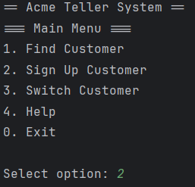
Step 2 | Continue with sign up:
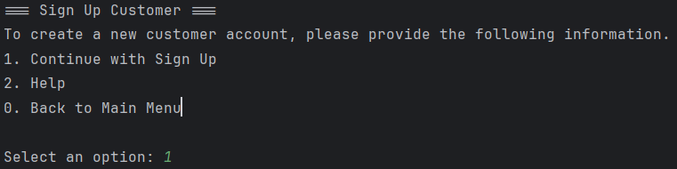
Step 3 | Insert name, national ID and passport number:
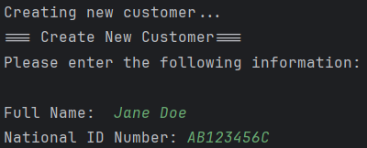
Step 4 | Address testing:
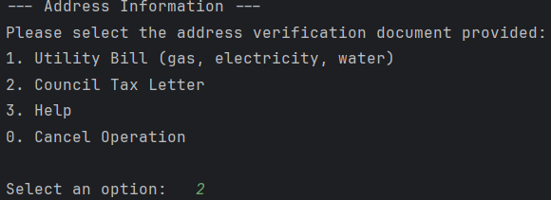
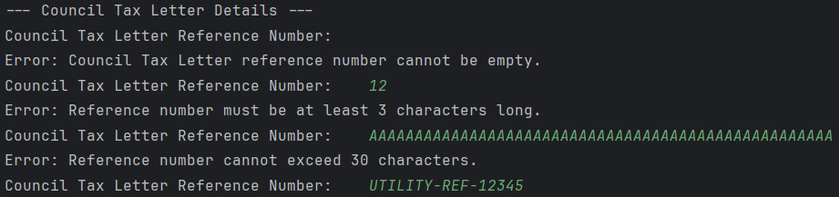
Test Number 2
Step 1 | Reach address verification:
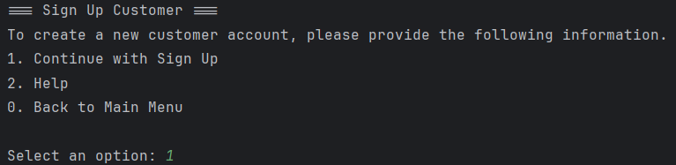
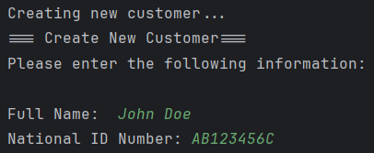
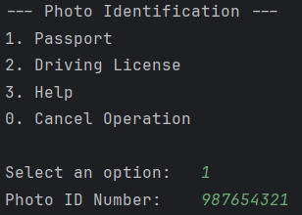
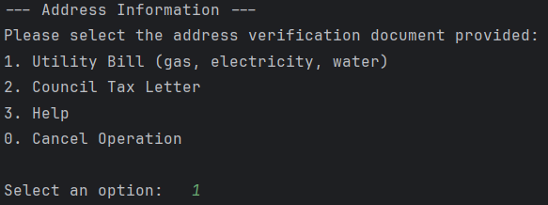
Step 2 | Test invalid inputs:
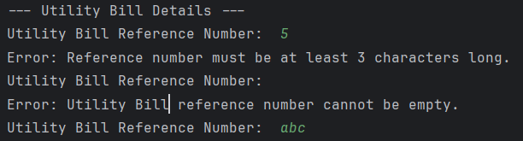
Step 3 | Test help feature
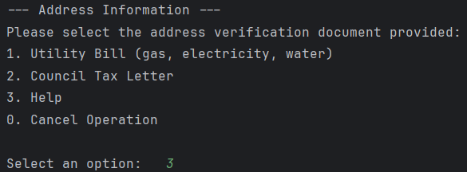
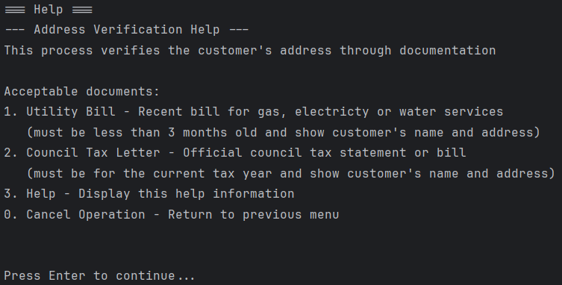
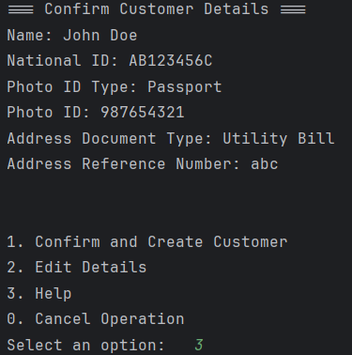
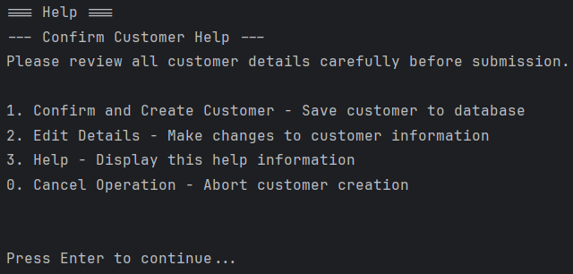
Step 4 | Test cancellation
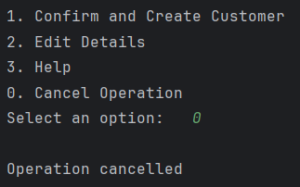
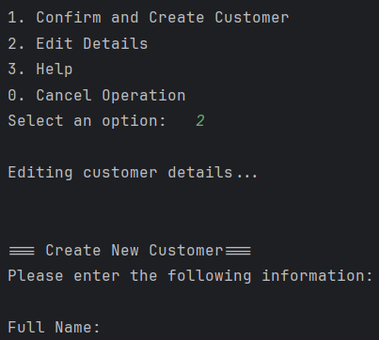
Test Number 3
Step 1 | Test various address reference formats:
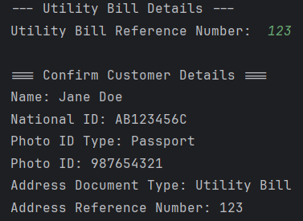
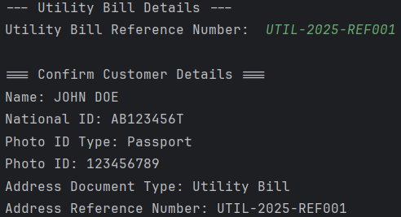
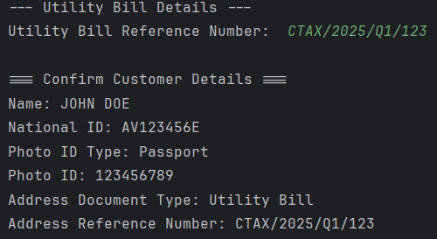
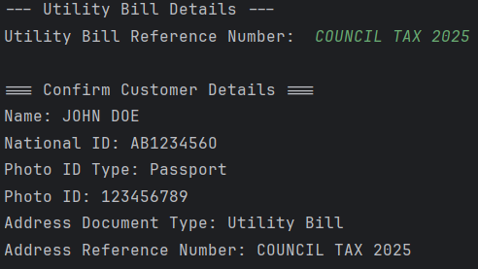
Step 2 | Test boundary conditions:
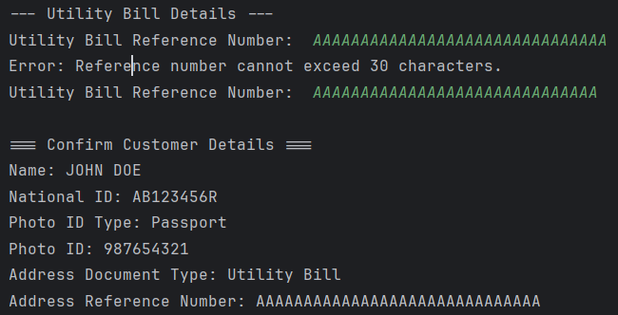
Step 3 | Test special characters:
